EXPERIMENT NO. 6

# Aim: Implement search functionality using Php and ajax.

Theory:

Ajax can be used to create more user friendly and interactive searches.

AJAX = Asynchronous JavaScript and XML. AJAX is a technique for creating fast and dynamic web pages. AJAX allows web pages to be updated asynchronously by exchanging small amounts of data with the server behind the scenes. This means that it is possible to update parts of a web page, without reloading the whole page.

Steps to create a live search of states using ajax:

Step 1: Create a database in localhost/phpMyAdmin/ and name it as ‘exp6’.

Step 2: Create table within it and name it as ‘states’. Name three columns as state_id, state_name and state_code.

Step 3: Later, create a form for live search.  Create a simple web interface that allows user to live search the names of states available in our country table, just like an autocomplete or typeahead.

Create a PHP file named "exp6.php"

Step 4: Create a .php file to process the query in backend. the source code in ‘q.php’ file which searches the database based on query string sent by the Ajax request and send the results back to browser.

OUTPUT:

Search Table:

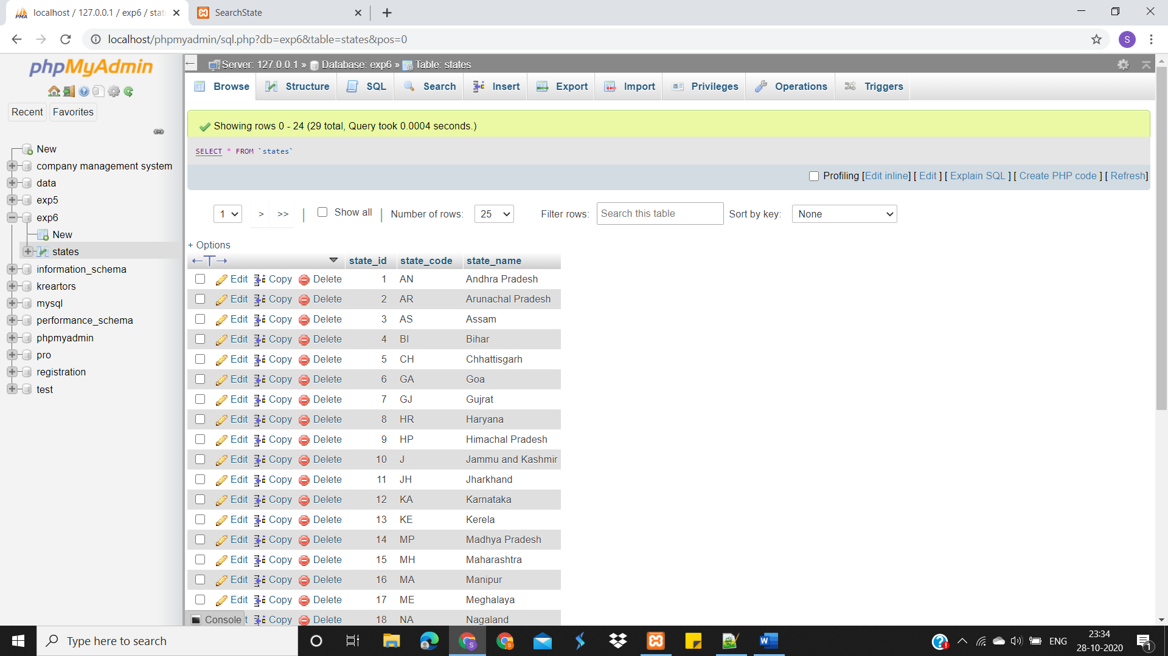

Search Interface:







Conclusion: Thus, we have implemented search functionality using Php and Ajax.